Name: P.Akshay reddy
Roll no:2420030122
Experiment 1: Case Study
Problem Statement: Choose a real-world case study such as an E-Commerce System or KL ERP System, create user stories, select an appropriate software development process model, identify a suitable programming language, and propose an implementation and evaluation strategy.
Real-World case study an online shopping platform
1. Functional Requirements
Customer
- Register and login
- Search products
- View product details
- Add products to cart
- Place orders
- Make online payments
- Track order status
- View purchase history
- Submit product reviews
Admin
- Manage products
- Manage categories
- Update inventory
- View customer details
- Process orders
- Generate sales reports

2. User Stories
User ID | User Story | Priority
US-01 | As a customer, I want to register so that I can purchase products. | High 8
US-02 | As a customer, I want to login securely. | High 6
US-03 | As a customer, I want to search products by name or category. | High
US-04 | As a customer, I want to add products to my shopping cart. | High
US-05 | As a customer, I want to remove items from the cart. | Medium2
US-06 | As a customer, I want to place an order. | High
US-07 | As a customer, I want to pay online securely. | High
US-08 | As a customer, I want to track my order. | Medium
US-09 | As an admin, I want to add new products. | High
US-10 | As an admin, I want to update stock levels. | High
US-11 | As an admin, I want to generate sales reports. | Medium
US-12 | As an admin, I want to manage customer accounts. | Medium
3. Selected Software Development Process Model
Agile Scrum
Reason for Selection
- Requirements change frequently.
- Continuous customer feedback.
- Incremental feature delivery.
- Faster development cycles.
- Easy bug fixing.
- Suitable for web-based applications.

Sprint Plan
Sprint | Features
Sprint 1 | User Registration & Login
Sprint 2 | Product Catalog & Search
Sprint 3 | Shopping Cart
Sprint 4 | Order Processing
Sprint 5 | Payment Gateway
Sprint 6 | Admin Dashboard
Sprint 7 | Testing & Deployment

4. Programming Language Selection
Backend
- Java (Spring Boot)
Reasons
- Secure
- Scalable
- Enterprise-level applications
- REST API support
- Excellent database connectivity
Frontend
- HTML5
- CSS3
- JavaScript
- React.js

Database
- MySQL
Other Technologies
- REST API
- JWT Authentication
- Stripe/Razorpay Payment Gateway
- Git
- Docker
- AWS Cloud

5. System Architecture
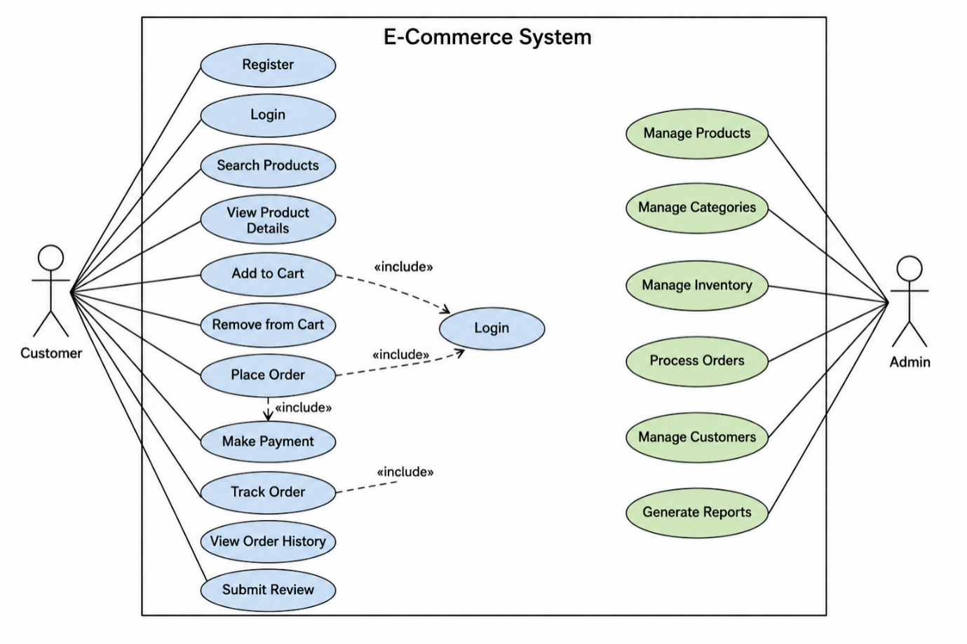

6. Implementation Strategy
Phase 1 – Requirement Analysis
- Gather customer requirements.
- Create Software Requirement Specification (SRS).
- Prepare use case diagrams.

Phase 2 – System Design
- Design database schema.
- Design UI wireframes.
- Create UML diagrams.
- Develop system architecture.
Phase 3 – Development
- Implement user authentication.
- Develop product catalog.
- Create shopping cart.
- Integrate payment gateway.
- Build admin dashboard.
Phase 4 – Testing
Unit Testing
- Login
- Registration
- Product search
Integration Testing
- Cart + Payment
- Order + Inventory
System Testing
- Complete application testing
User Acceptance Testing (UAT)
- Verify business requirements.

Phase 5 – Deployment
- Docker Container
- AWS EC2
- MySQL Database
- Nginx Web Server

7. Evaluation Strategy
Evaluation Parameter | Method
Functional Accuracy | Requirement verification
Performance | Load testing using JMeter
Security | Authentication and penetration testing
Reliability | Continuous monitoring
Usability | User feedback survey
Scalability | Concurrent user testing
Maintainability | Code review and documentation

10. Expected Outcomes
- Secure online shopping platform.
- Fast product search.
- Reliable order management.
- Accurate inventory updates.
- Secure online payments.
- Improved customer satisfaction.
- Scalable architecture for future enhancements.

